**Day 40**

**Java finally block**

**Java finally block** is a block used to execute important code such as closing the connection, etc.

Java finally block is always executed whether an exception is handled or not. Therefore, it contains all the necessary statements that need to be printed regardless of the exception occurs or not.

The finally block follows the try-catch block.

Flowchart of finally block

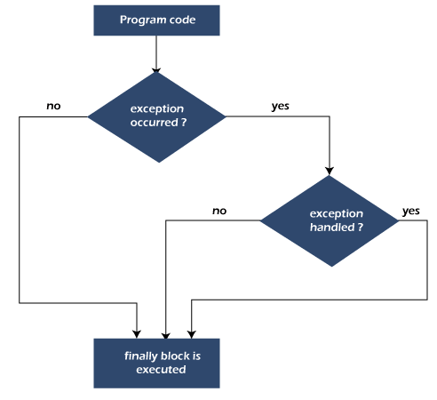

Note: If you don't handle the exception, before terminating the program, JVM executes finally block (if any).

Why use Java finally block?

* finally block in Java can be used to put "**cleanup**" code such as closing a file, closing connection, etc.
* The important statements to be printed can be placed in the finally block.

**Java throw Exception**

In Java, exceptions allows us to write good quality codes where the errors are checked at the compile time instead of runtime and we can create custom exceptions making the code recovery and debugging easier.

Java throw keyword

The Java throw keyword is used to throw an exception explicitly.

We specify the **exception** object which is to be thrown. The Exception has some message with it that provides the error description. These exceptions may be related to user inputs, server, etc.

We can throw either checked or unchecked exceptions in Java by throw keyword. It is mainly used to throw a custom exception. We will discuss custom exceptions later in this section.

We can also define our own set of conditions and throw an exception explicitly using throw keyword. For example, we can throw ArithmeticException if we divide a number by another number. Here, we just need to set the condition and throw exception using throw keyword.

The syntax of the Java throw keyword is given below.

throw Instance i.e.,

1. **throw** **new** exception_class("error message");

Let's see the example of throw IOException.

1. **throw** **new** IOException("sorry device error");

Where the Instance must be of type Throwable or subclass of Throwable. For example, Exception is the sub class of Throwable and the user-defined exceptions usually extend the Exception class.